**Installations:**

Java

Maven

**Execution:**

To run the script from a Terminal/Command Prompt

1. Open the terminal/Command Prompt and navigate to the folder where the scripts are. They are in the workspace/folder. Navigate till 'BeachWeatherForecastAPIAutomation'. eg., /Users/amarnathvattigunta/Desktop/autotoauto/BeachWeatherForecastAPIAutomation

Then type the following command and click on enter.

mvn test verify -Dcucumber.options="--tags @forecast"

**Reports:**

Navigate to project and reports can be found in below location.

/AustraliaBeachesWeatherForecast/target/report/cucumber-html-reports/report-feature_3620947105.html

**Logs:**

BeachWeatherForecastAPIAutomation/src/test/java/Logs/APILog.log

**Sreenshot of BUILD SUCCESS**

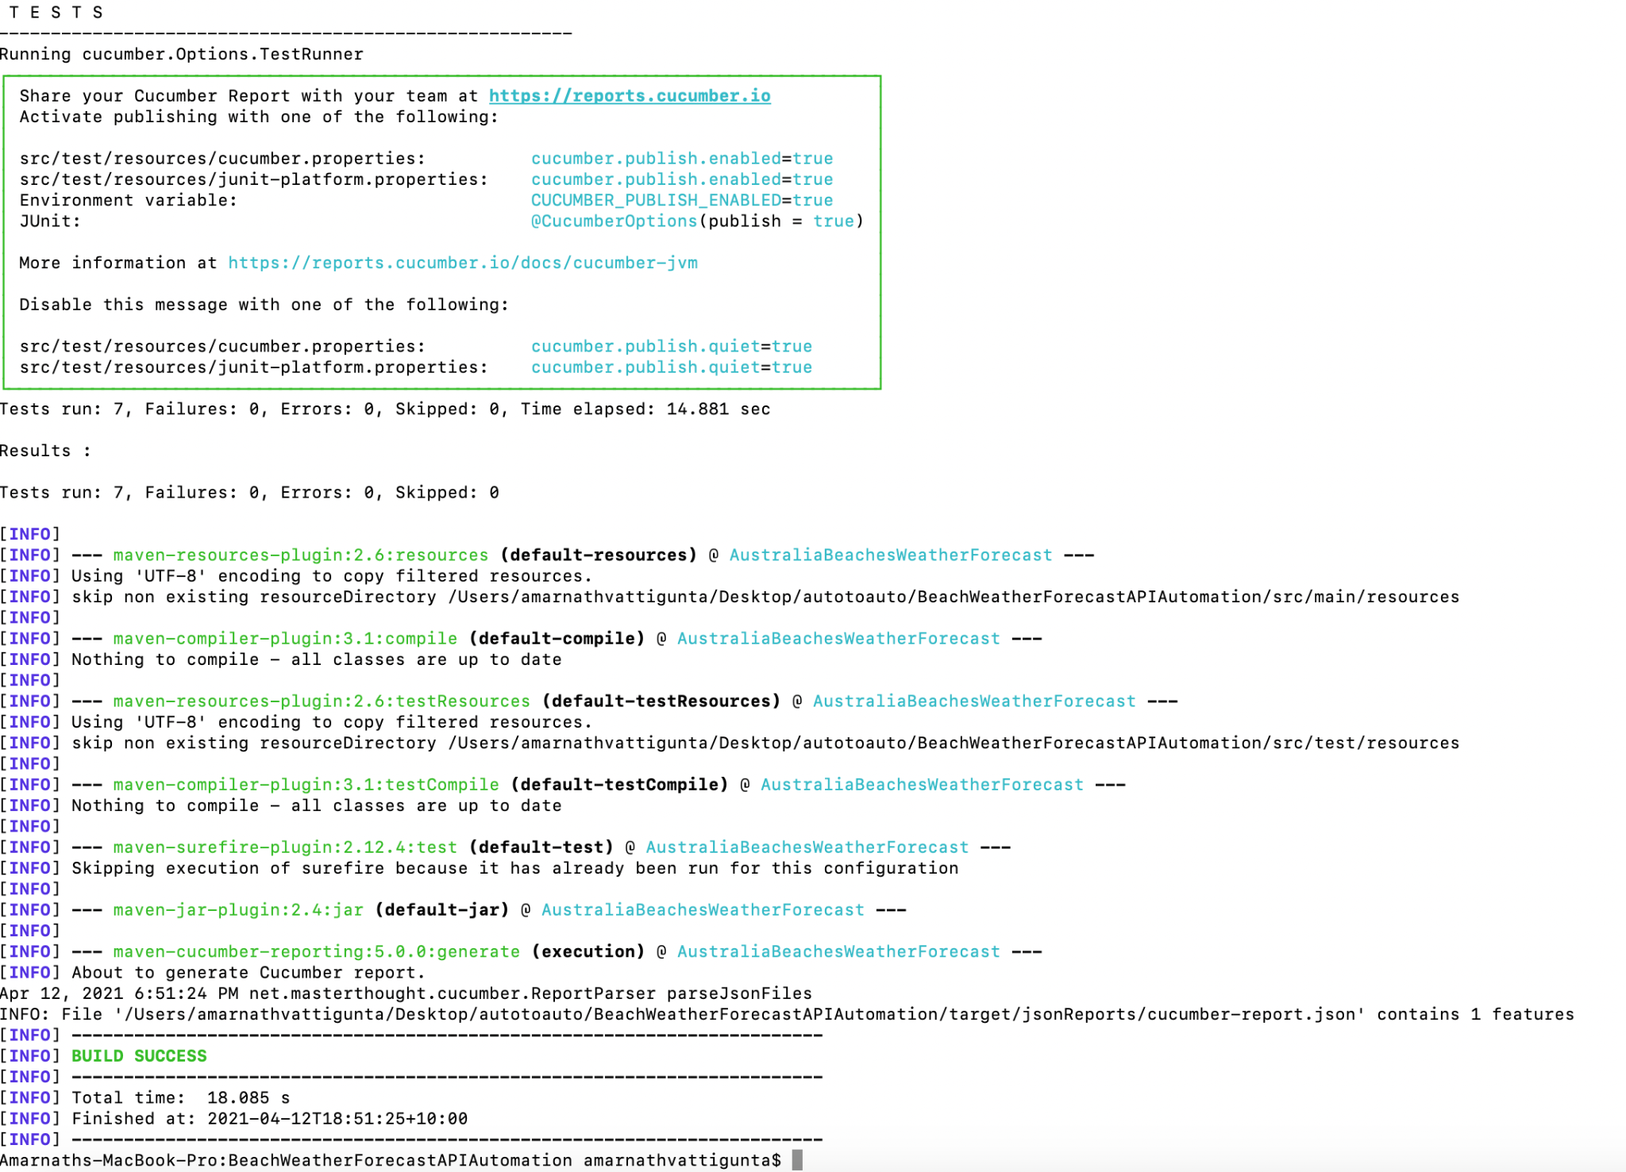

**Screenshot for report**

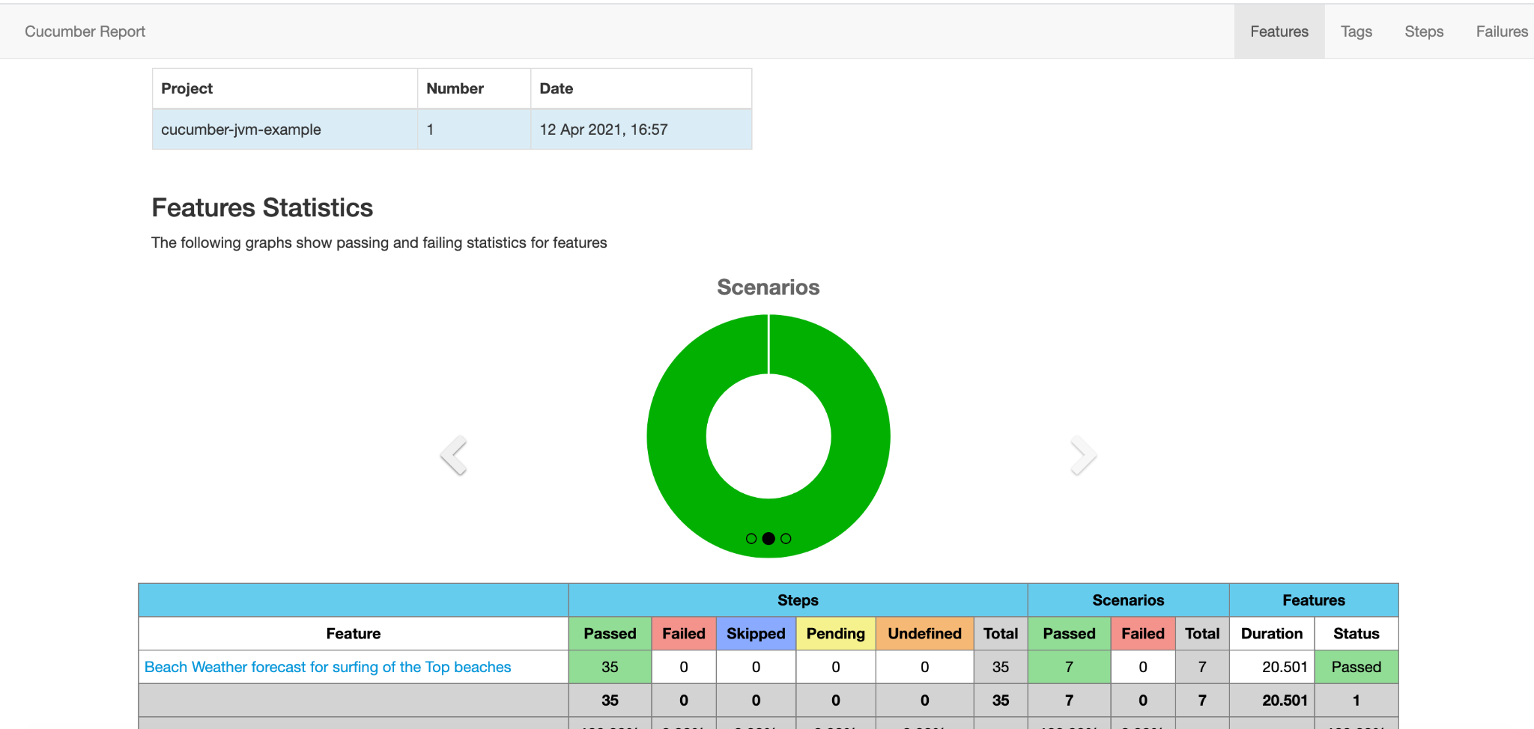

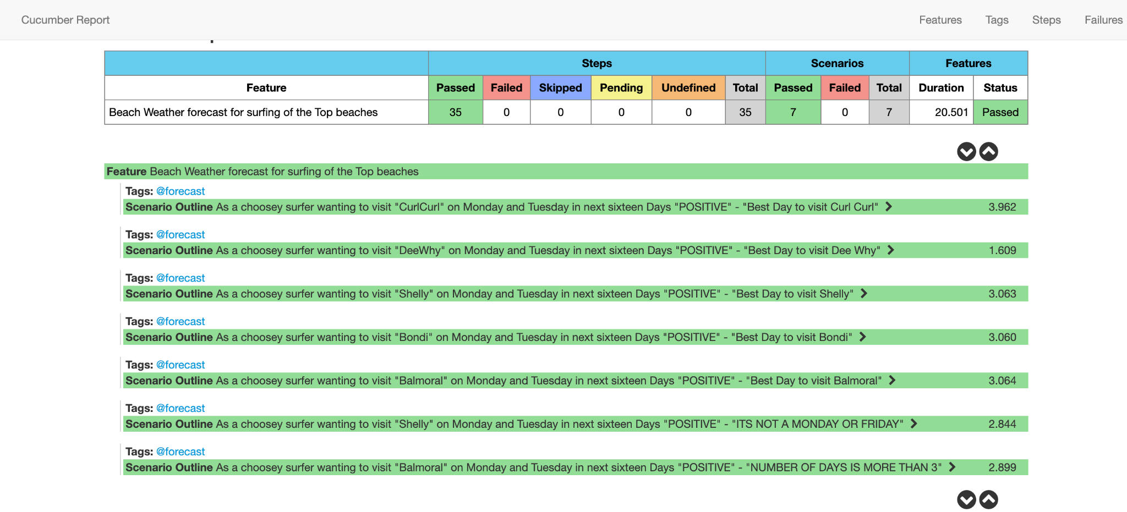

**Screenshots for Logs**

**RestAssured Logs**

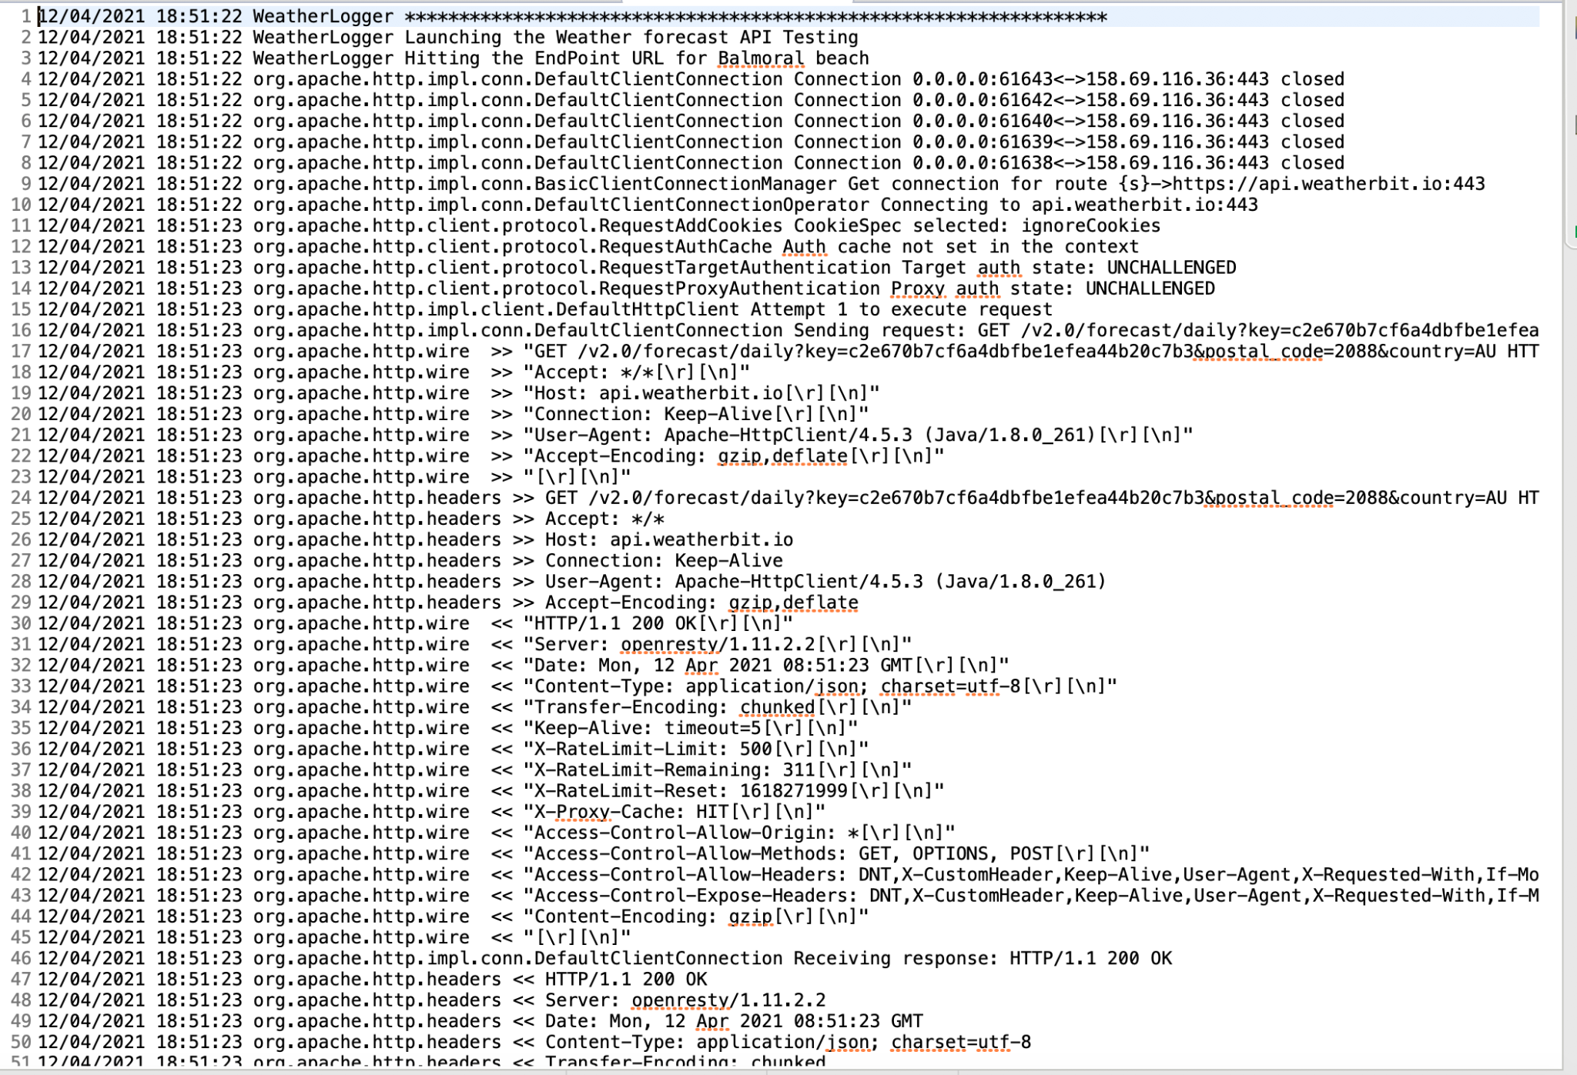

**API Logs**

